Thirupathi rao .v 192211896

Activity 5 pointers

Single catch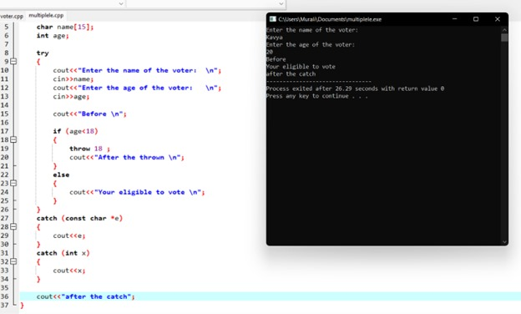

Multiple catch

